### SHRI SHAMBHUBHAI V. PATEL COLLEGE OF COMPUTER SCIENCE & BUSINESS MANAGEMENT, SURAT.

**VEER NARMAD SOUTH GUJARAT UNIVERSITY, SURAT.**

#### PROJECT REPORT ON

“Hello Dreamy Birds”

### AS A PARTIAL REQUIREMENT FOR THE DEGREE OF

**BACHELOR OF COMPUTER APPLICATION [B.C.A]YEAR: 2021-22**

|  |  |
| --- | --- |
| ***SUBMITED BY :*** | ***GUIDED BY :*** |
| Devanshi Mukundbhai Akbari | Prof. Pratiksha Patel |
| Harsh Himmatbhai Dhameleeya |  |
| Bhumi Jiteshbhai Dudhat |  |



* Ms .Devanshi akbari (2019021229):

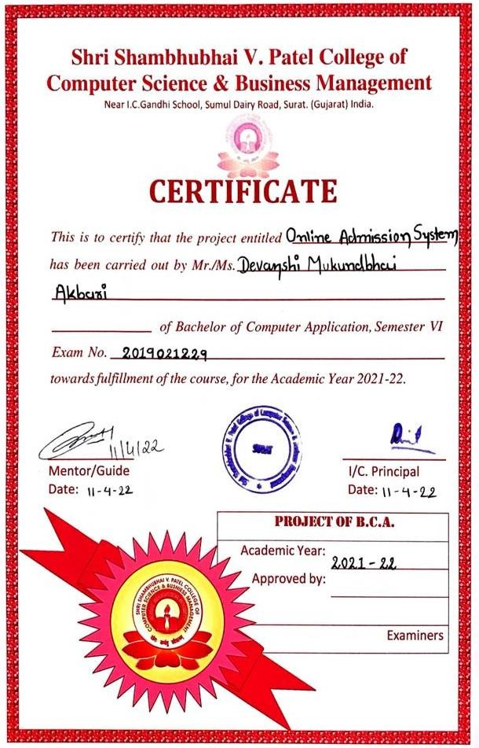

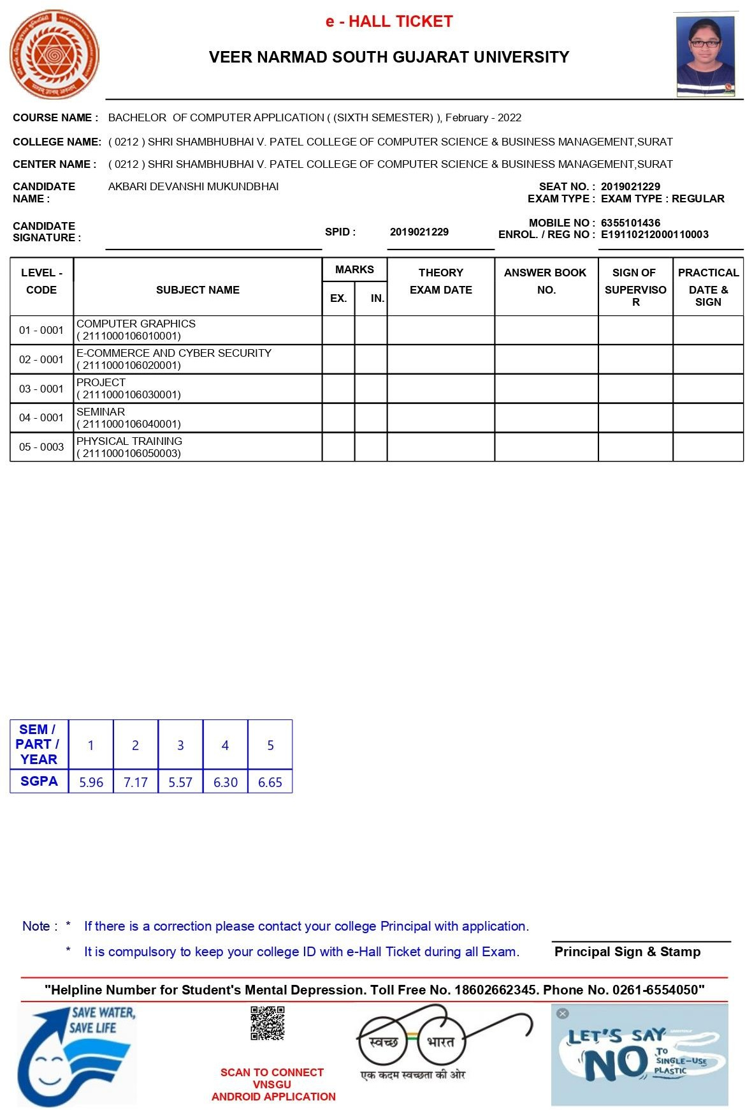



* Mr. Harsh Dhameleeya (2019021229):

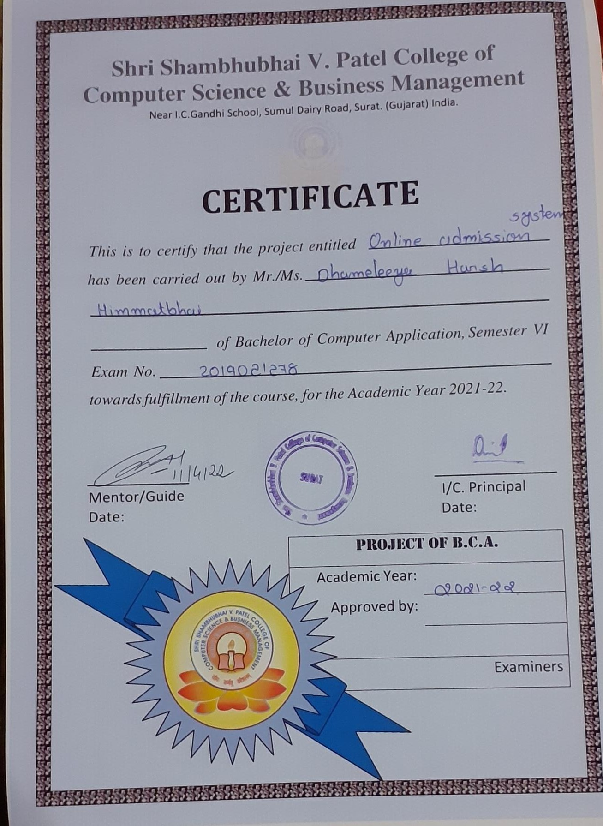

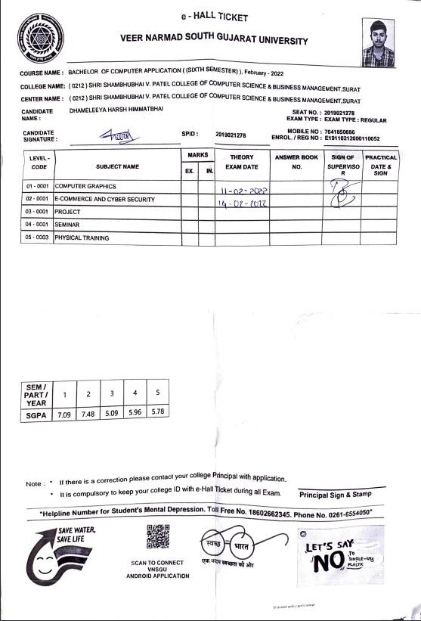



* Ms. Bhumi Dudhat (2019021295):

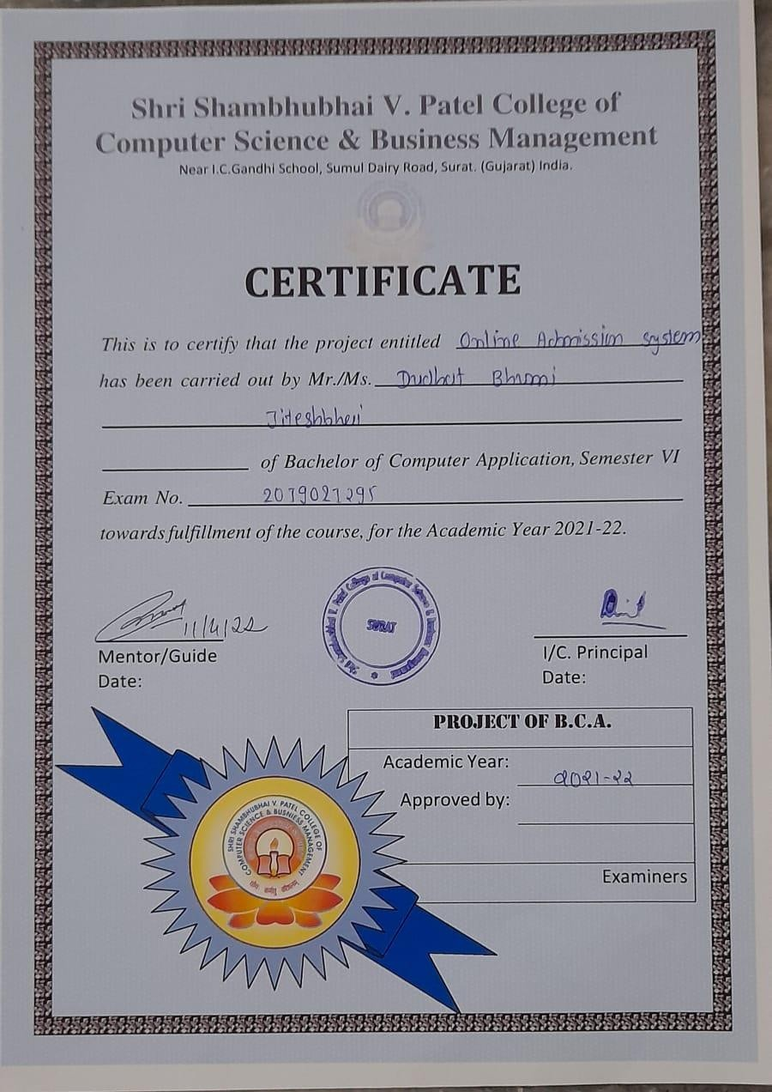

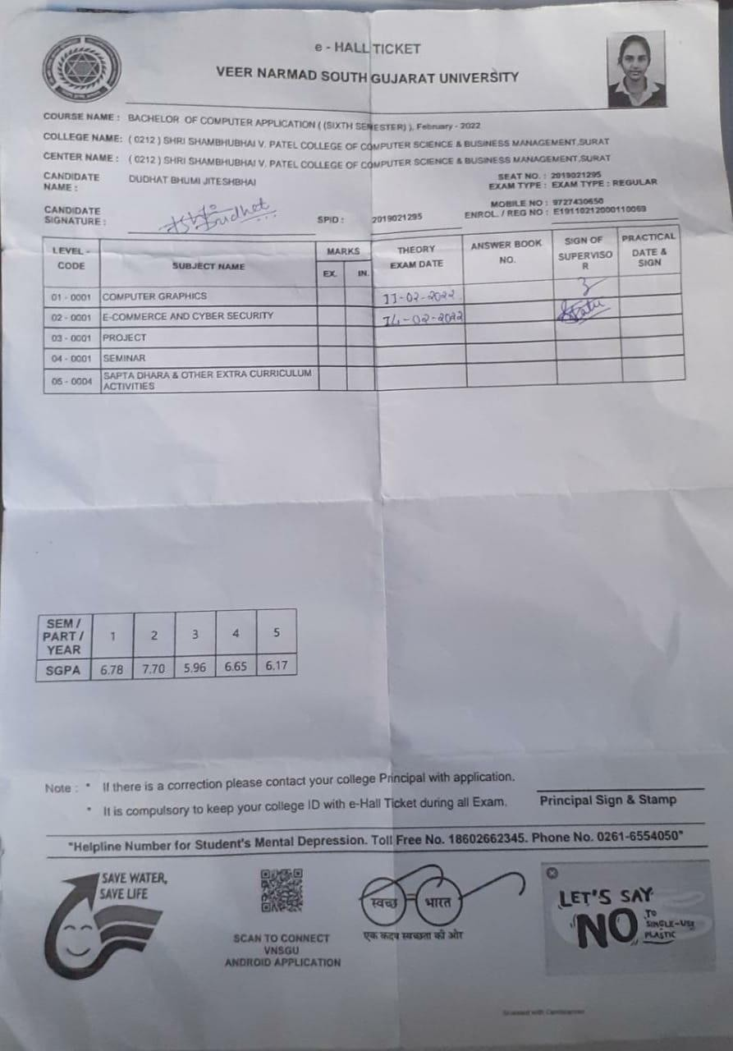



# PREFACE

* Before Tasking the Project Work for Foundation, It Is Quite Necessary to Have an Exact Idea the Work “Project”. The Project Consist of Seven Letters Each Letter Has Its Own Significance as Follow.

‘P’ For Planning

‘R’ For Resource

‘O’ For Operation

‘J’ For Joints Efforts

‘E’ For Engineering Function

‘C’ Communication

‘T’ Task of Working

* We Happy to Hand-Over This Project to The **Shri Shambhubhai V. Patel College of Computer Science & Business Management**. This Project is

“Online Admission System” for Institutes, Collages and University.

* In A Computer Application Studies, The Practical Training is very important. We can improve theoretical knowledge by Reading and Attempt Class but It Is Imperfect without Getting Practical Knowledge.
* Begin an IT Student, We Should See Every Side of Technical Unit. It Perform Virtual Role in Developing Software and Situation Opportunities and Problems.
* Here, We Are Presenting a Project on the Different Concept. We Have Tried Our Level best to do proper justification in this project.



# Acknowledgement

* Our Self Ms. Devanshi Akbari, Mr. Harsh Dhameliya & Ms. Bhumi Dudhat have opportunity to express our knowledge. We would like to express our gratitude to all those who gave us the possibility to complete our project. We want to thanks to Signature Infosys for giving me permission to Do Project Work in their Organization.
* Prof. Pratiksha Patel – Our professor and project coordinates has been very prudent to us threw out the Collage Studies. They are the Person who has giving this Direction to Our Work and The shape to our Imagination. We express our regard to them from the core of our heart.
* We also like to thanks our all the professor who are always ready to give best guide. They are the person who give solution whenever needed.
* We would also like to acknowledge all the Friends and Colleagues, Team member for the help and encouragement by them for Time to Time. The constant Support and Encouragement of my Friend is deeply appreciates. The Project indeed gave Challenging and Exhilarating experience in Designing and Developing the Required System.



**INDEX**

|  |  |  |
| --- | --- | --- |
| **Sr. No** | **Chapter Name** | **Page No** |
| **1.** | **Introduction** | **11** |
|  | **1.1 Project Profile** |  |
|  | **1.2 Objective** |  |
|  |  |  |
| **2.** | **System Environment** | **14** |
|  | **2.1 Hardware and Software Requirement** |  |
|  | **2.2 Technology Used** |  |
|  |  |  |
| **3.** | **Existing System** | **20** |
|  | **3.1 System Components** |  |
|  | **3.2 Drawbacks Of Existing System** |  |
|  |  |  |
| **4.** | **System Planning** | **23** |
|  | **4.1 Feasibility Study** |  |
|  | **4.2 Requirement Analysis and Data Gathering** |  |
|  |  |  |
| **5.** | **Proposed System** | **26** |
|  | **5.1 Scope** |  |
|  | **5.2 Expected Advantages** |  |
|  |  |  |
| **6.** | **Detailed Planning** | **28** |
|  | **6.1 Data Flow Diagram & UML** |  |
|  | **6.2 Process Specification** |  |
|  | **6.3 Data Dictionary** |  |
|  | **6.4 Entity - Relationship Diagram** |  |
|  |  |  |
| **7.** | **System Design** | **40** |
|  | **7.1 Database Design** |  |
|  | **7.2 Directory Structure** |  |
|  | **7.3 Input Design** |  |
|  | **7.4 Output Design** |  |
|  |  |  |
| **8.** | **Software Testing** | **53** |
|  |  |  |
| **9** | **Limitation and System Enhancement** | **56** |
|  |  |  |
| **10.** | **Bibliography** | **57** |



**INTRODUCTION**

* **Project Profile**

|  |  |
| --- | --- |
| **Project Title** | Hello Dreamy Birds |
| **Front End** | HTML, CSS, JavaScript, jQuery |
| **Back End** | PHP, MySQL |
| **Internal Guide** | Prof. Pratiksha Patel |
| **Submitted To** | Shri Shambhubhai V. Patel College of Computer Science & Business Management, Surat. |
| **Developed By** | Ms. Devanshi Akbari Mr. Harsh Dhameliya Ms. Bhumi Dudhst |



**About Project**

#### * Project Definition

The Hello Dreamy Birds which is developed for any admission or educational process that is delivered to learners through an electronic device, this project is developed for universities and also for students to search their courses and find the colleges or universities online.

The Hello Dreamy Birds is an Extensive and Powerful script written in PHP with windows. Give the platform to global education search marketplace with this script. Web seekers can post their requirements through this website and the service providers can place courses and sites.

#### * Features

* + Inquiry Follow-ups.
  + Online application form filling and submission.
  + 24 x 7 Availability of application forms.
  + Password protected Pre Registration process.
  + Online fees payment processing.
  + Facility for Branch Sliding.

## OBJECTIVE

#### * Objective of the system

* It Provide the Platform Where User Can Able to take admission anytime & anywhere.
* In Our Website after higher study, everybody can take admission in an easy way.
* We Provide the Facility to Uses that he/she can able to take admission in the single collage at a time.
* It Provide the Platform Where User Can compare collages.
* We provide the admission letter to all Users Who get confirmation by respective admin after meet requirement.
* We have experienced educational institutes who provide better education to our users.
* Suitable Videos related to particular course are provided at our site which is easy for novice users.
* With the online tools that enable course comparison, students can compare course, collage and fees to make a better decision with best choice.



#### *Constraints

* The constraint associated in the development of any software system includes those that are common to all system. The common constraints may include lack of managerial participation tighter development schedule etc.
* Some of the constraints are listed below with which we have developed this system:
* User mistake can be turned into the improper answer.
* The common constraints may include lack of managerial participation tighter development schedule frequently working for management etc.
* It has some specification need: to run this software because is developed in the PHP with Windows.
* Net connection and other web related software are required.



## ENVIRONMENT

#### Hardware and Software Requirement

The efficient hardware and software configuration required to run the system is as suggested below. The configuration suggested is adequate. Same functionality or higher configuration will always be better.

#### Hardware Configuration

|  |  |
| --- | --- |
| **Hard Disk** | 10 GB (or above) |
| **RAM** | Minimum 512 MB ( 1GB ) |
| **Processor** | Quad-core |

* **Software Configuration**

|  |  |
| --- | --- |
| **Operating System** | Windows 2003 server or above (Any System) |
| **Database** | MYSQL |
| **Development** | VS Code |
| **Server** | Apache |



* **Overview of PHP**

**Technology Used for Development**

* Precisely, PHP is a very powerful server-side scripting language like ASP for developing dynamic web applications. Using PHP, you can build interactive and dynamic websites with ease. If you have some idea about the C language, then learning PHP should be a fairly simple task for you.
* It is free, it is suitable for web development, it is efficient, it is widely used and it is considered to be the most powerful alternative to Microsoft’s ASP. PHP script can be embedded straight into the heart of html code just like ASP.
* One of the reasons of the why PHP is getting more popular is that its syntax is very much similar to that of C and Perl. PHP is compatible with various web servers like Apache and the Microsoft’s IIS as well. All the PHP scripts are executed on the server (Apache, IIS etc.) and it supports various databases like MySQL, Oracle, Solid, Generic ODBC etc.; however, it is mostly used with MySQL. Another reason for the ever-increasing popularity of PHP is that it is free to download and use.
* What does a PHP file contain is a common question asked by many PHP learners? A PHP file has an extension of .html, .php or .php3 and it may contain various HTML tags, texts and scripts. Although a .php file contains scripts but when it is returned to the browser, it is returned as a plain HTML file. We shall learn more about PHP in our coming sections.



#### Features of PHP

##### Standard CGI, Fast CGI and Apache module support

As a standard CGI (Common Gateway Interface) program, PHP can be installed on any UNIX machine running any UNIX web server. With support for the new Fast CGI standard, PHP can take advantage of the speed improvements gained through this mechanism. As an Apache module, PHP becomes an extremely powerful and lightning-fast alternative to CGI programming.

##### Access Logging

With the access logging capabilities of PHP, users can maintain their own hit counting and logging. It does not use the system's central access log files in any way, and it provides real-time access monitoring. The Log Viewer Script provides a quick summary of the accesses to a set of pages owned by an individual user. In addition to that, the package can be configured to generate a footer on every page which shows access information. See the bottom of this page for an example of this.

##### Access Control

A built-in web-based configuration screen handles access control configuration. It is possible to create rules for all or some web pages owned by a certain person which place various restrictions on who can view these pages and how they will be viewed. Pages can be password protected, completely restricted, logging disabled and more based on the client's domain, browser, e-mail address or even the referring document.

##### PostgreSQL Support

Postures is an advanced free RDBMS. PHP supports embedding PostgreSQL "SQL queries" directly in .html files.



#### OVERVIEW OF XAMPP

* XAMPP is an abbreviation for cross-platform, Apache, MySQL, PHP and Perl, and it allows you to build site offline, on a local web server on your computer. This simple and lightweight solution works on Windows, Linux, and Mac – hence the “cross-platform” part.
* XAMPP provides two essential components for its installation – Apache, which is used to create the local server, and MySQL which you can use as a database for your website. It allows them to create a local copy of the site in which they can try out new plugin updates before implementing them on its live version. This way they can prevent and spot potential errors and issues that might occur.

#### OVERVIEW OF MY SQL

* The MySQL pluggable storage engine architecture enables a database professional to select a specialized storage engine for a particular application need while being completely shielded from the need to manage any specific application coding requirements.
* The MySQL server architecture isolates the application programmer and DBA from all of the low-level implementation details at the storage level, providing a consistent and easy application model and API.
* Thus, although there are different capabilities across different storage engines, the application is shielded from these differences.



#### MySQL Architecture with Pluggable Storage Engines

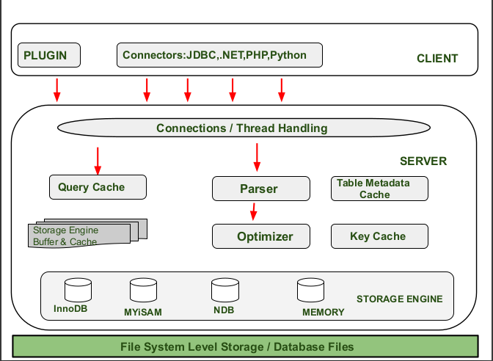

**(Figure: 2.2.1)**

* + - The pluggable storage engine architecture provides a standard set of management and support services that are common among all underlying storage engines. The storage engines themselves are the components of the database server that actually perform actions on the underlying data that is maintained at the physical server level.
    - This efficient and modular architecture provides huge benefits for those wishing to specifically target a particular application need—such as data warehousing, transaction processing, or high availability situations—while enjoying the advantage of utilizing a set of interfaces and services that are independent of any one storage engine.
    - The application programmer and DBA interact with the MySQL database through Connector APIs and service layers that are above the storage engines. If application changes bring about requirements that demand the underlying storage engine change, or that one or more storage engines be added to support new needs, no significant coding or process changes are required to make things work.
    - The MySQL server architecture shields the application from the underlying complexity of the storage engine by presenting a consistent and easy-to-use API that applies across storage engines.



#### Features of MySQL

##### Relational Database System:

Like almost all other database systems on the market, MySQL is a relational database system.

MySQL is a client/server system. There is a database server (MySQL) and arbitrarily many clients (application programs), which communicate with the server; that is, they query data, save changes, etc. The clients can run on the same computer as the server or on another computer (communication via a local network or the Internet).

##### SQL compatibility:

MySQL supports as its database language -- as its name suggests – SQL (Structured Query Language). SQL is a standardized language for querying and updating data and for the administration of a database. There are several SQL dialects (about as many as there is database systems). MySQL adheres to the current SQL standard (at the moment SQL: 2003), although with significant restrictions and a large number of extensions.

##### Stored procedures:

Here we are dealing with SQL code that is stored in the database system. Stored procedures (SPs for short) are generally used to simplify certain steps, such as inserting or deleting a data record. For client programmers this has the advantage that they do not have to process the tables directly, but can rely on SPs. Like views, SPs help in the administration of large database projects. SPs can also increase efficiency. MySQL has supported SPs since version 5.0.

##### Foreign Key Constraints:

These are rules that ensure that there are no cross references in linked tables that lead to nowhere. MySQL supports foreign key constraints for InnoDB tables.

##### Platform Independence:

It is not only client applications that run under a variety of operating systems; MySQL itself (that is, the server) can be executed under a number of operating systems. The most important are Apple Macintosh OS X, Linux, Microsoft Windows, and the countless Unix variants, such as AIX, BSDI, FreeBSD, HP-UX, Open BSD, Net BSD, SGI Iris, and Sun Solaris.



## EXISTING SYSTEM

#### System Components

System component engineering is actually a set of concurrent activities that address each of the system components separately: software engineering, hardware engineering, human engineering, and database engineering.

Each of these engineering disciplines takes a domain-specific view, but it is important to note that the engineering disciplines must establish and maintain active communication with one another.

Workflow Management Software automates definition, delegation and distribution of tasks. By using this system, you will be able to accelerate team performance. This system is customized for dynamic teamwork.

You will be organized, productive, and effective by using this system and can easily track projects / tasks, notify your personnel’s, and automate your routine work.

By using workflow, the need to hold lengthy coordination meetings is removed, because everyone can see what is coming next in the job queue

The components of the System are as follows: -

##### Administrator

1. **User**



##### The Administrator

* As an Administrator you can achieve the following tasks by using this system:
  + Active / Deactive Admission.
  + Manage Courses.
  + Manage Feedback (Admission / User).
  + Manage Subscription.
  + Manage Admission Process.
  + View All Uploaded Documents.
  + Select/Reject And Give Review To Student.

##### User

* Following are the cases that you must consider and accord to:
  + First of all, you should provide your valid details (like name, email id, contact information, date of birth, qualification, etc.) to the administrator.
  + After, you have been successfully added as a user member in the System.
  + After this, you would see your User interface, which you simply need to follow and it will automatically guide you through your work.
* You can achieve the following tasks by using this system
  + You can choose course in application form.
  + You can upload documents for admission.
  + You can ask your query.
  + You can also change your login password and other information before accepted your request.
  + Simply logout from the system, after completion of your work.



##### Drawbacks of Existing System



* **Feasibility Study**

## SYSTEM PLANNING

Feasibility study is the process of determination of whether or not a project is worth doing. Feasibility studies are undertaken within tight time constraints and normally culminate in a written and oral feasibility report. The contents and recommendations of this feasibility study helped us as a sound basis for deciding how to precede the project. It helped in taking decisions such as which software to use, hardware combinations, etc.

##### Technical Feasibility

The website being developed in the total open source environment hence it does not require and presumes higher & advanced technology. It is completely a project based on Online Admission site. Thus the system is so developed and made functional with high end functions to get the relevant facilities as per the admin's desire in the less time.

##### Economic Feasibility

As the website being totally platform independent due to use of open source technology, it doesn't demand any extra cost of setting up a network or any other installation cost to use the website. Thus it is also economically feasible, as it frees the end-user from any other overheads.

##### Operational Feasibility

Operational feasibility is a measure of how well a proposed system solves the problems, and takes advantage of the opportunities identified during scope definition and how it satisfies the requirements identified in the requirements analysis phase of system development. Hence forth, the system developed was also operationally feasible.

* Our project guide –Prof. Pratiksha Patel guided us to take proper care and check for the operational feasibility of the system.
* Efforts were made to optimize the human efforts in data collection, storage, retrieval, security and presentation.
* The proposed system made best efforts in achieving necessary function and performance, as required by the user and keeping in mind some infrastructure constraints.



**Requirement Analysis and Data Gathering**

Software Requirement Analysis is required after understanding the scope of the system to be built. I did decide to go for Xampp server because of its various advantages like portability, multi-user support and many more and the backend that was required MYSQL database because it provide big data concept which is required for Online Admission site.

##### Design: -

Designing was the next major task. Proper designing is the basis of a successful project. It also removes lots of vulnerabilities later on. For my project I divided the whole concept into a number of modules.

##### Code Generation: -

The design is to be translated in a machine-readable form during this phase of the project. Coding was the second major task. Coding was done in parallel, as much as possible. The average time spent in coding was nearly 70% of the total time.

##### Testing: -

Testing was done on a regular basis during the coding phase itself. Also a separate session was kept for testing. Some errors were uncovered and the code was modified to ensure the removal of error. Extensive testing was done to ensure the correctness of the project. Also a list of desired outputs was made and the code was tested to see if the outputs are consistent.

##### Support: -

Software will undoubtedly undergo change after it is delivered to the User. The software is evaluated and a plan for its improvement is drawn up. Realization of what a user expected from the system and what he actually got is possible only after it is evaluated for a reasonable amount of time.



* **Authentication of members**
  + Creation of student’s account
  + Authorization of student account

#### Different types of modules

* + Login
  + Admission Management
  + University Management
  + Application Management

#### Student

* + Login
  + Student Registration
  + Course Management
  + University Management

#### Admin

* + University Management
  + Course Management
  + Student Management
  + Fees Management
  + Admission Management
  + Event Management
  + Document Management
  + Notice Management



## PROPOSED SYSTEM

#### Scope

##### Main Aim of the System

Website provides a way for Online Admission System by viewing different courses and Online Admission System allows students to take admission to save traveling time to visiting and get knowledge of courses and spend their time on other important tasks and hobbies.

##### Scope of System

* + - Website can able to manage the students and also their details of a course for online admission.
    - Website can able to provide the best security level to the members of the site for authenticate student online.
    - Website is able to introduce new important notice that can be aware students for knowing new things.
    - Student are freed from the pressure of documant from the home to collage/university and can spend more time to make wise course decisions.
    - The computerized system names “Online Admission System” such easier and faster it has solved problem for admission management, reduce Paper work done by existing system, reduce some Entry work in system.
    - Website is also good at the security level means that the web-user or other unauthorized web user will not be able to get all details of the students.
    - Website gives the best way for the registration of new students and join the portal.



## OBJECTIVE

#### Objective of the system

Students desire a variety of courses because they look for the right course that will fully satisfy them. There is variety of course available online because online admission system allows Students to browse through courses that are made all around the world without geographical boundaries. The system allows the Admin to manage all kind of courses and maintain it for each student.

#### Constraints

The constraint associated in the development of any software system includes those that are common to all system. The common constraints may include lack of managerial participation tighter development schedule etc.

Some of the constraints are listed below with which we have developed this system:

* The common constraints may include lack of managerial participation tighter development schedule frequently working for management etc.
* It has some specification need: To run this software because is developed in the PHP with Windows.
* Net connection and other web related software are required.



**Expected Advantages**

#### High Security

There is high security mechanism provided by the proposed system. No unauthorized person can make change in the data those are stored in website. Only authorized person can change & also can make login.

#### Less Time Required

In our website, all the processes are carried out by computer so obviously it will require less time than traditional admission system and in that sense; in will require less time to complete admission process.

#### High Amount of Accuracy

The website will perform all guidance and manipulation automatically; in that case the data that we receive will be accurate and much more reliable than the data that generated previously.

#### Easy to use

Online Admission System is accessible round the clock. You can take admission whatever you want even at 3 a.m. in the morning. You can choose from a wider variety of courses available for you, which may not be available in the traditional manner. You also have the benefit to do all from the comfort of your own home. When you take admission from online admission system you have the comfort to take your time while checking for the things of your choice, this will lead you to a simple and quick way to perform comparison unlike the dissatisfied and hurried admission you do in the traditional way.



**DETAIL PLANNING**

### Data Flow Diagram

The data flow diagrams are an intuitive way of showing how data is processed by a system.

The symbols used in the DFD for this project are shown below.

#### DATA FLOW

Following symbol is used to show data flow. The data flow is packet of data.

#### PROCESSES

People, procedures or devices that use or produce data.



#### SOURCE OR DESTINATION OF DATA

These are the entities, which interact with the system from outside its boundaries.

#### DATA STORAGE

Here data are stored or referenced process in the system.

In the DFD diagram we define the flow of data and how the system data flow managed by grouping the data with the entity relationship. In this way we find out the need of the system and managed it in particular way by which we can easily access with the system.

By the use of DFD diagram all the complete data fellow is understood by the system analysis. Here in our DFD there is a once the patient is going for treatment the management of hospital first inform the patient that which kind of treatment is available and what kind of task is performed by the person and which kind of function should be implemented by the management person who is managing.



* **Data Flow Diagram & UML (**Unified Modeling Language**)**
  + User flow chart

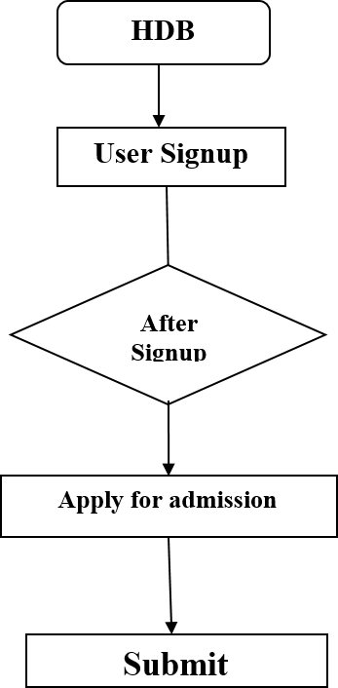

* + Admin flow chart

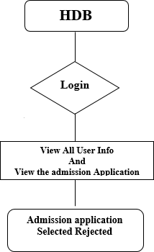



#### User Case Flow Diagram

* 1. User

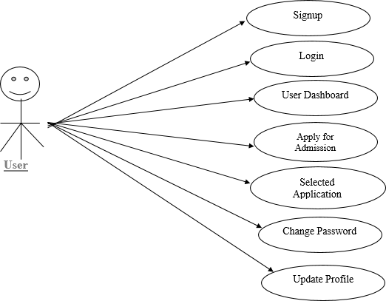

* 1. Admin

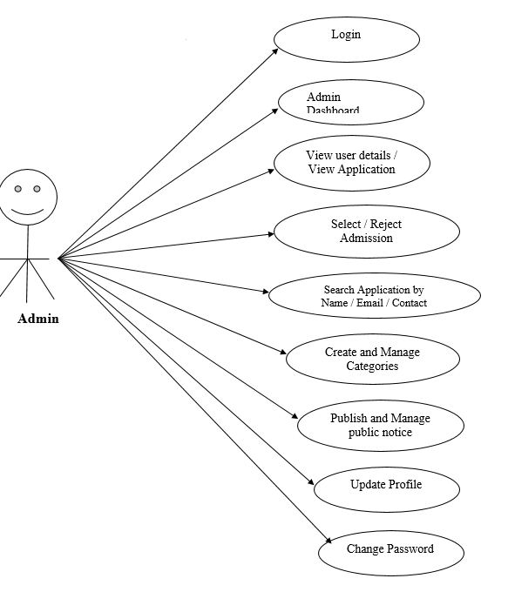



#### PROCESS SPECIFICATION

* **User**

1

Registration detail

Registration

User

1) It Receive Registration Detail from Web-User/Store

And Store In Registration Table.

* **Login**

2

User Id and Password

User Profile

Login

Process

1. Auto Logout If You insert Wrong password.
2. Successfully Login To Move Your Profile.



* **Personal Details**
* **Feedback**

3

Add detail

Personal details

Personal

Details

1) Add Personal Detail and This Information store In the User Table.

18

User

Feedback

Feedback

1) It Receive Feedback For website From User. And Show Feedback.



* **Give Application**

User

16

Add App.

Pending application

1. To Perform Add application for selected collages and Registration Must Be Requiring.
2. User Can Add application

* **Approved application**

Application

1

Manage Application

Approved App.

1. University can approve application.
2. Admin Can Manage It.



##### Fees

User

3

Online pay

University

1. Student will pay fees for further study.
2. Admin Can Manage fees table.

* **Event Booking**

19

Admin

Event

Book

Event

1) Admin Can Book Event. 2) Admin Can Manage Event.



## Data Dictionary

##### Login

|  |  |
| --- | --- |
| **Name** | Login |
| **Source** | Web-User / Admin / University |
| **Destination** | User |
| **Description** | Web-user / University and Admin Can Login with Your Valid User ID and Password and Redirect in Your Profile. |

* **User Registration**

|  |  |
| --- | --- |
| **Name** | User |
| **Source** | Visitor |
| **Destination** | User |
| **Description** | Any New Visitor Can Fill Registration Form and Become Member. |

##### Admin Registration

|  |  |
| --- | --- |
| **Name** | University registration |
| **Source** | University |
| **Destination** | User |
| **Description** | Any New University Can Fill Registration Form and Become Member. |



* **Courses**

|  |  |
| --- | --- |
| **Name** | Course |
| **Source** | University |
| **Destination** | Course |
| **Description** | University adds new Course detail which is stored into the course table And Show On Webpage With Proper Manner. |

* **Notice**

|  |  |
| --- | --- |
| **Name** | Notice |
| **Source** | Web-User / Admin |
| **Destination** | Users |
| **Description** | New notice about course and fees are stored in notice table. |

##### Fees

|  |  |
| --- | --- |
| **Name** | Fees |
| **Source** | Web-User / University |
| **Destination** | University |
| **Description** | Whenever Student Pay Fees From Online At System Will Be Implement And Become A Fees for a course And fees Details Are Stored In fees table. |



##### Subscriber

|  |  |
| --- | --- |
| **Name** | subscriber |
| **Source** | Web-User |
| **Destination** | Admin |
| **Description** | If User is Registered, then it can count in subscriber. That all are  stored into this table . |

* **Feedback**

|  |  |
| --- | --- |
| **Name** | Feedback |
| **Source** | Web-User / University / Visitor |
| **Destination** | Feedback |
| **Description** | Web-user and Visitor are given Feedback And that all Feedback is manage by Admin and also stored in this table. |



## Database designcamv2 Class Diagram



**SYSTEM DESIGN**

* **Database Design**

 Admin Table:

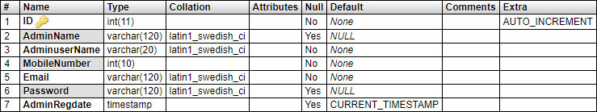

 User Table:

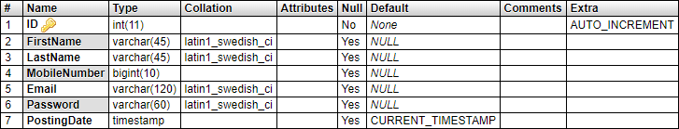

 Course Table:





 Application Table:

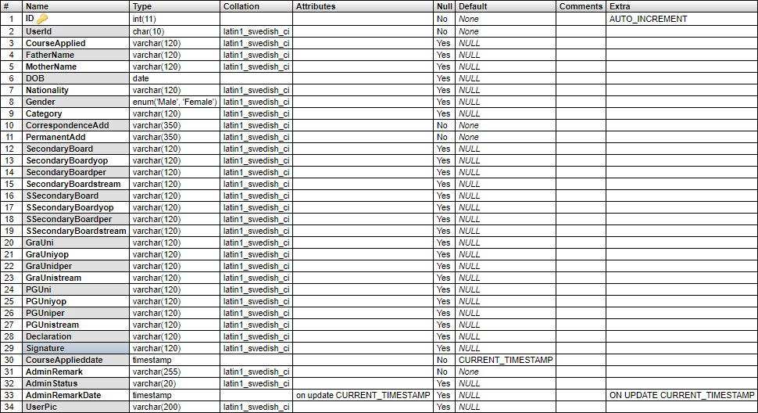

Document Table:

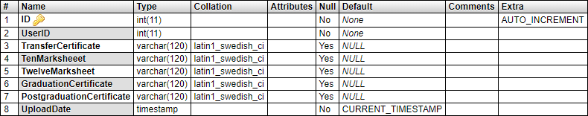



Fees Table:

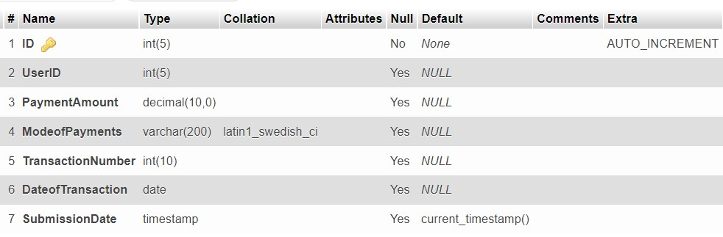

Contact Table:

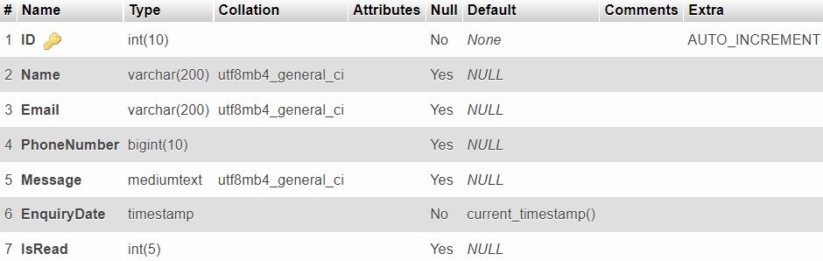

Notice Table:

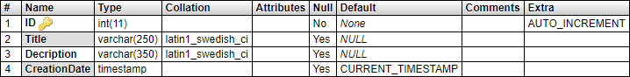



## Directory Structure

* + **Static Page**

|  |  |
| --- | --- |
| **Index.php** | Contain Detail Of Basic Information About Website. |
| **Admin.php** | Contain Detail of All Database Management. |
| **Feedback.php** | Contain User Side Feedback. |
| **Contact Us.php** | Contain Details Contact Us Page Of Website. |
| **About Us.php** | Contain Details About Us Page Of Website. |
| **Course.php** | Display all course of the University. |
| **Registration.php** | Form For New Visitor For User. |
| **Fees.php** | Form For pay fees of courses. |
| **Notice.php** | Contain Details of Notice about students. |
| **Event.php** | Contain Details of Events of collages. |



**Input Output Design**

##### Index.php



* + - **About Us.php**

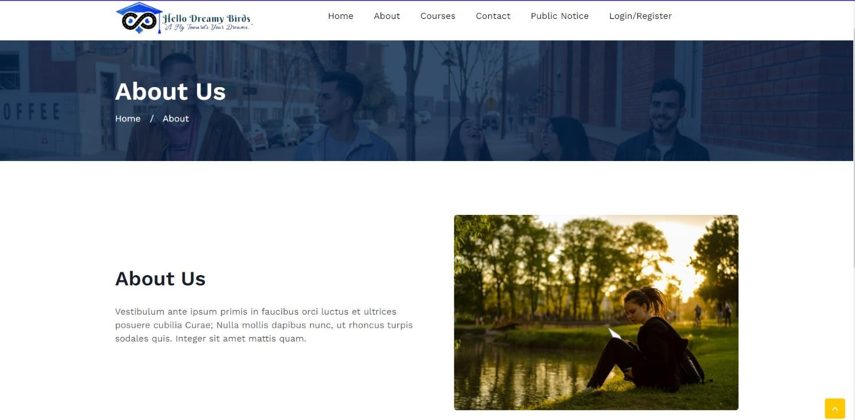



##### Contactus.php

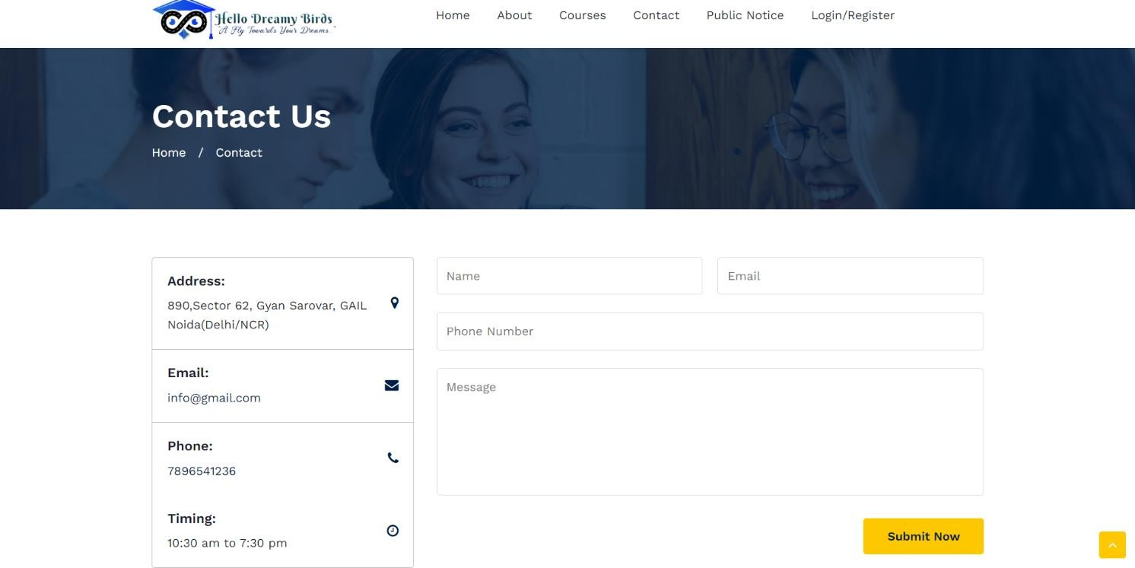

* + - **Courses.php**

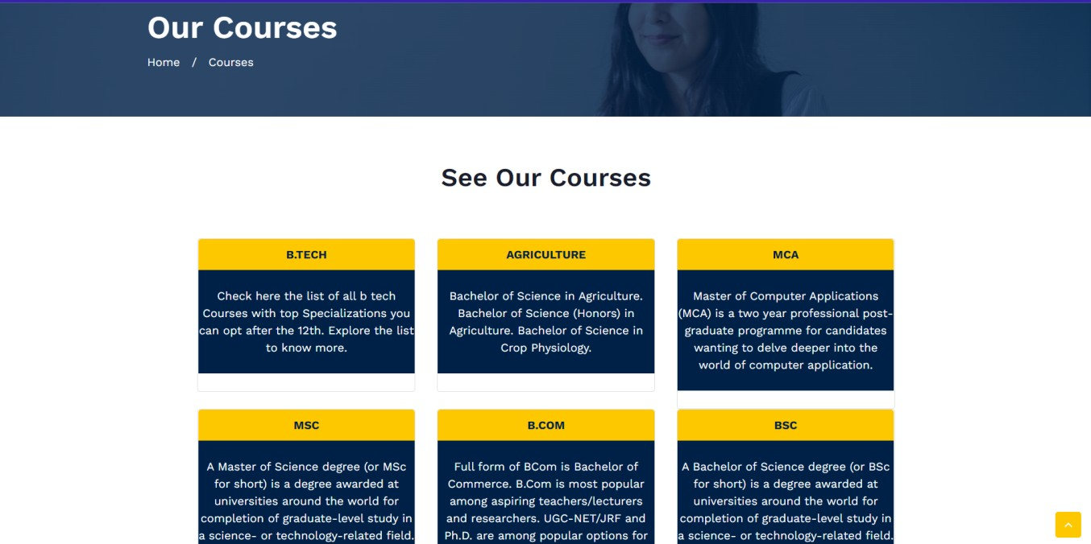



##### Notice.php

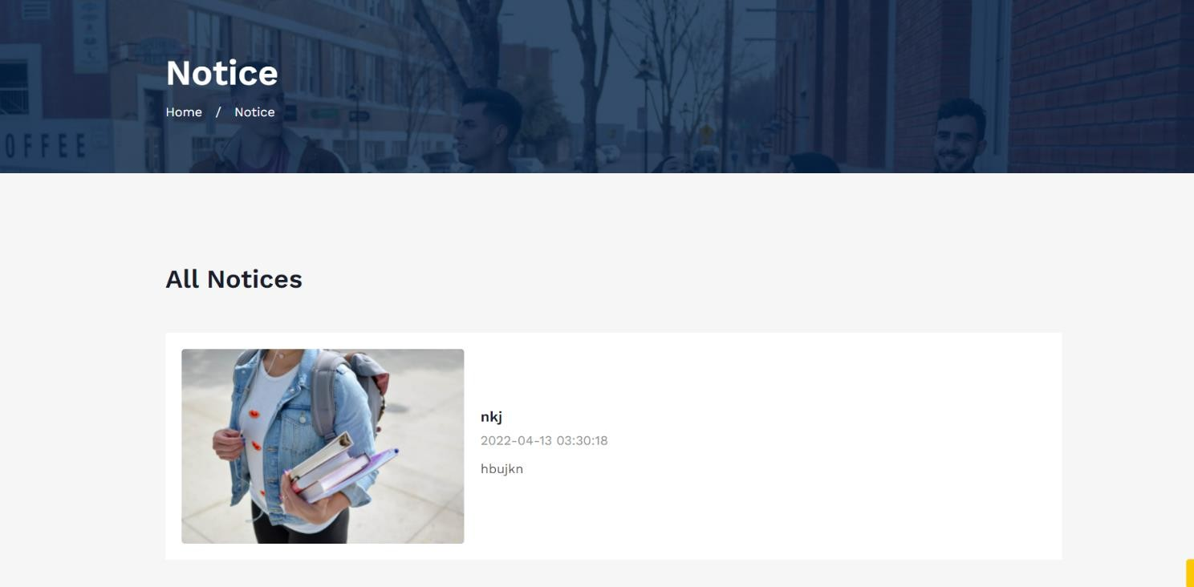

* + - **Login.php**

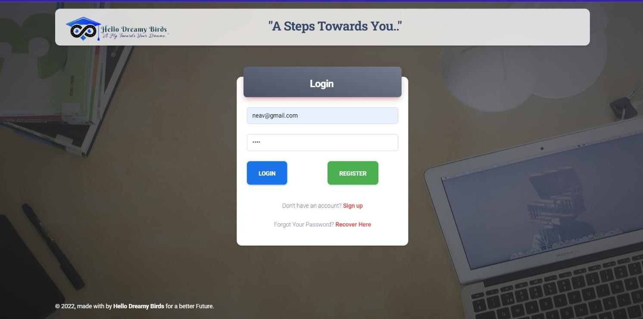



##### Register.php

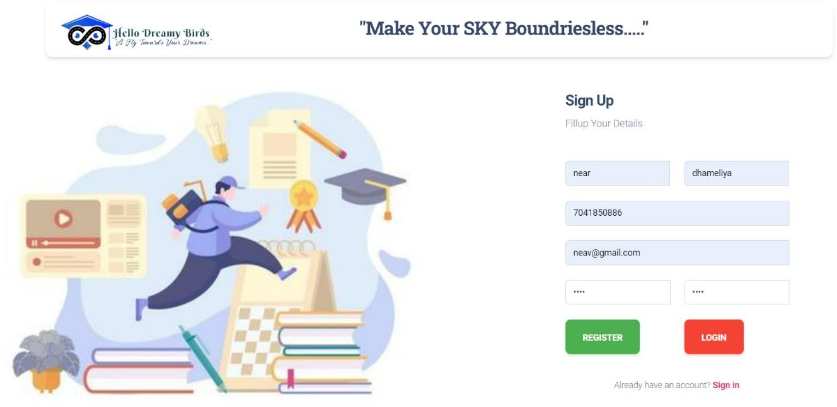

* + - **Dashboard.php**

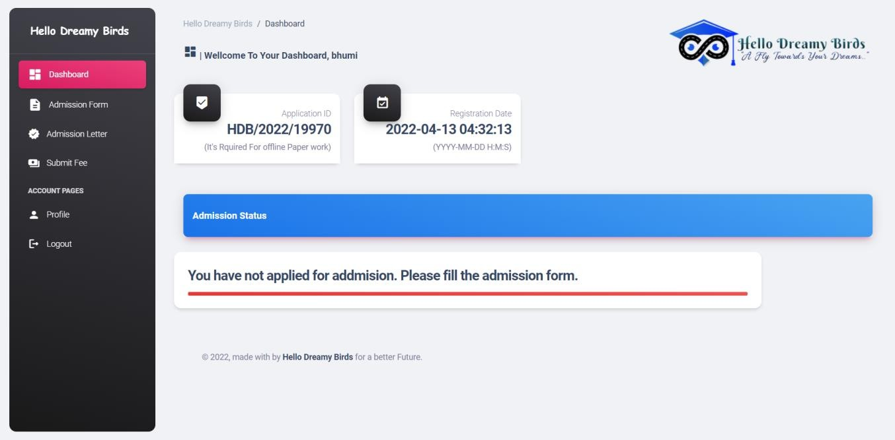



##### Application Form.php

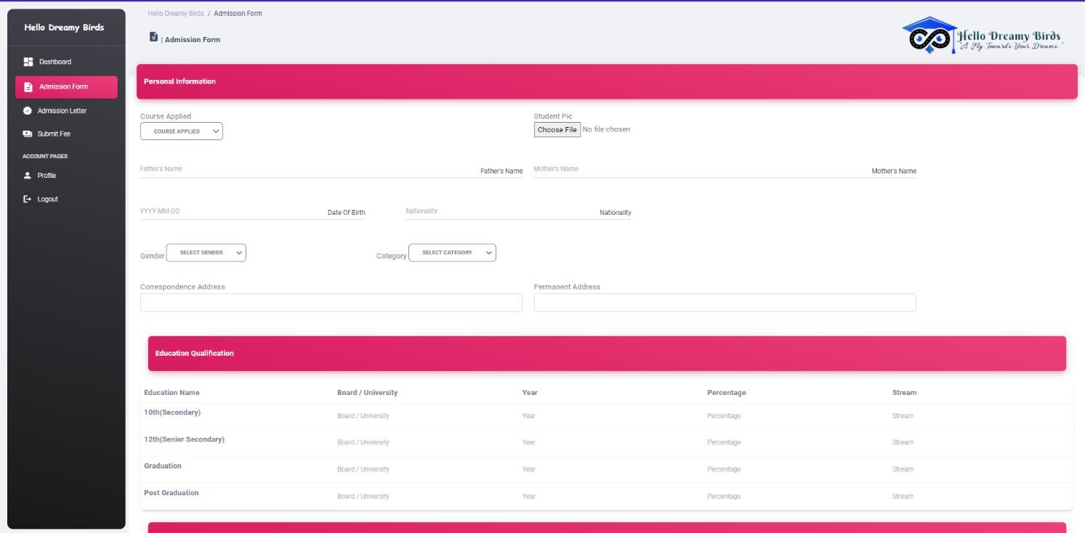

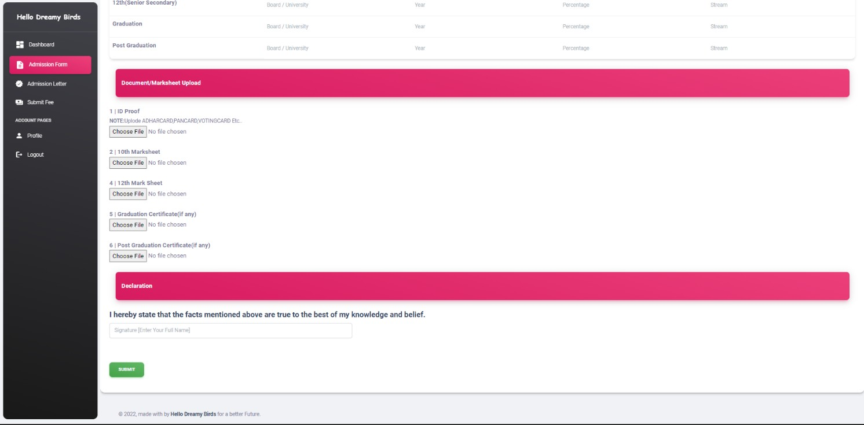



* + - **Admission letter.php**

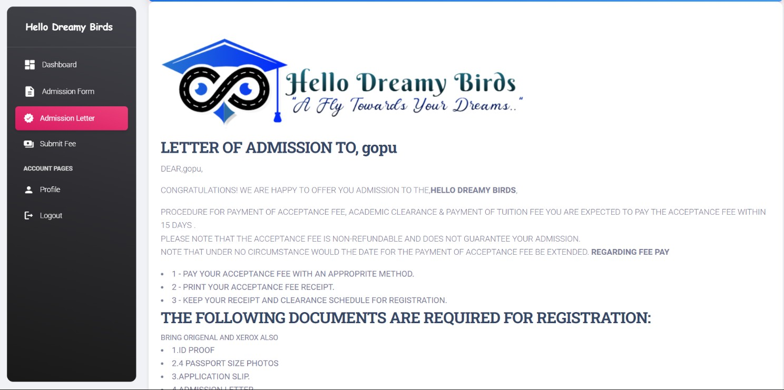

##### Fees.php

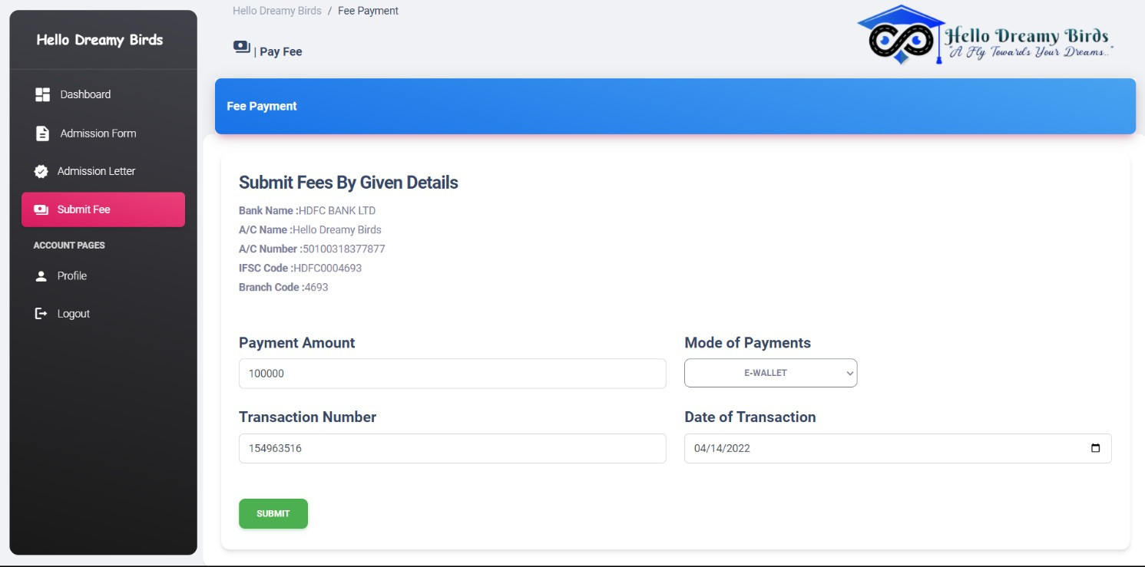



* + - **Admin.php**

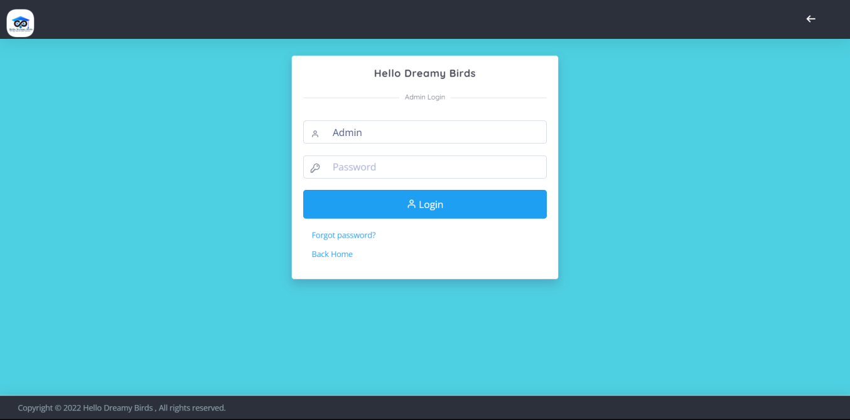

##### Admin-Dashbord.php

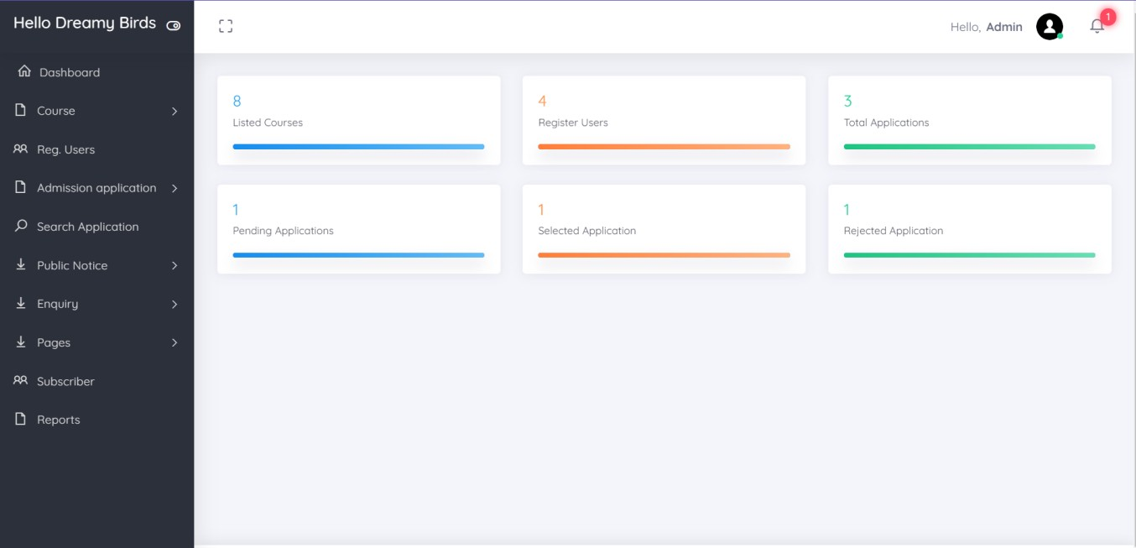



* + - **Admin-Course.php**

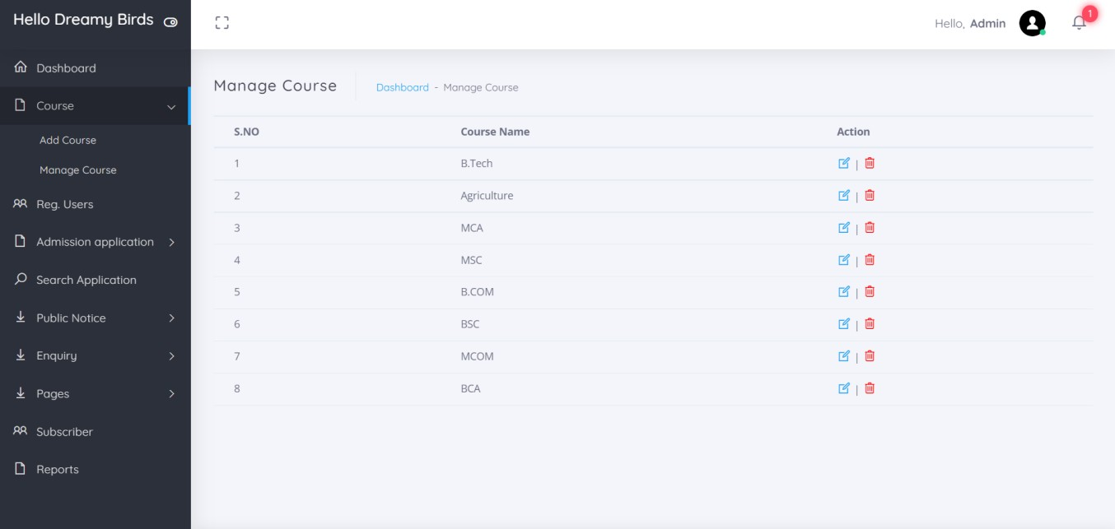

##### Admin-Reg.user.php

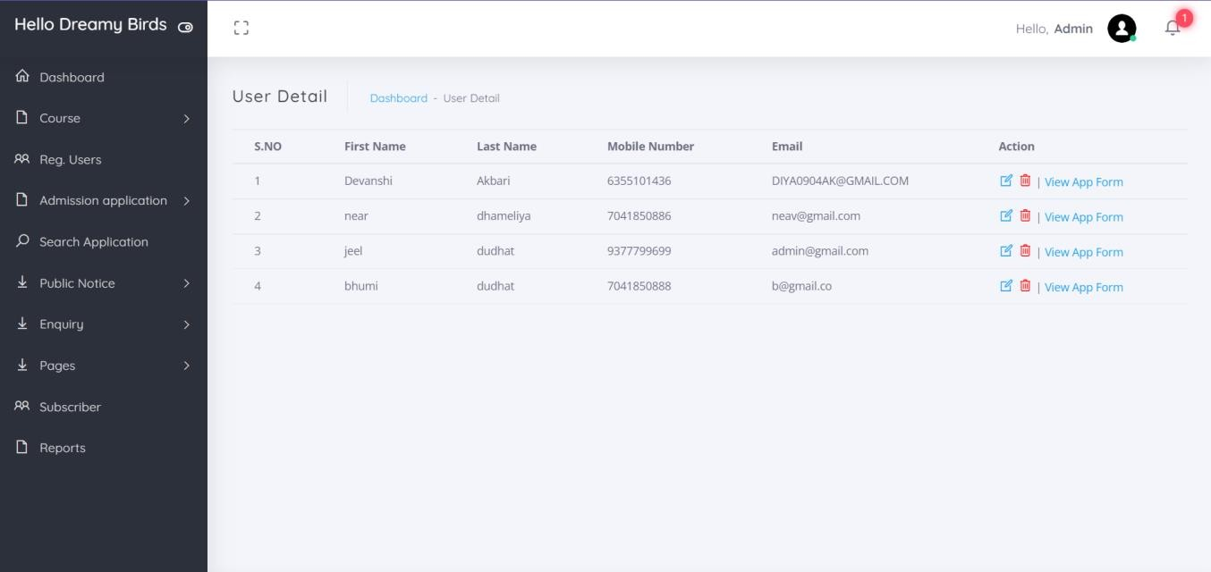



* + - **Admin-application.php**

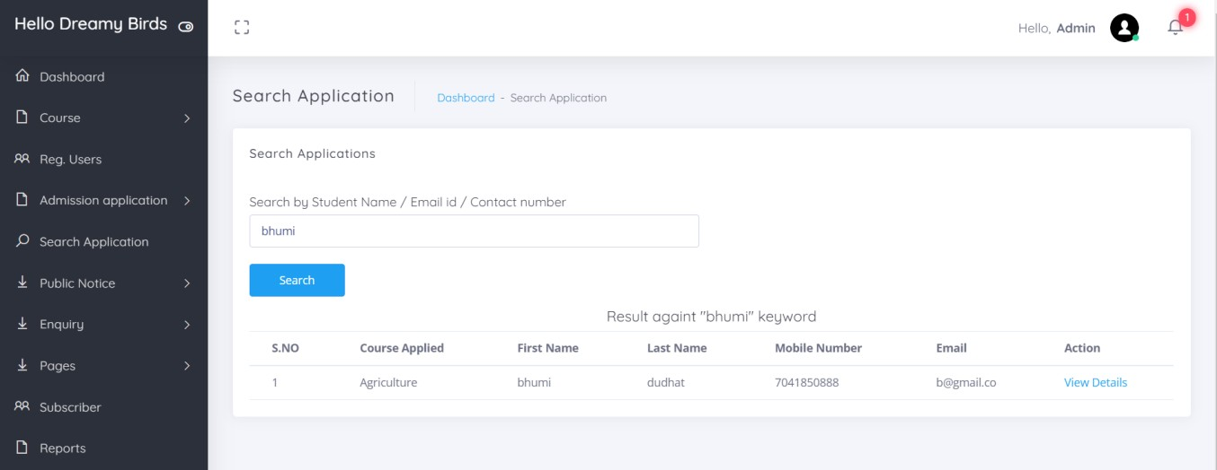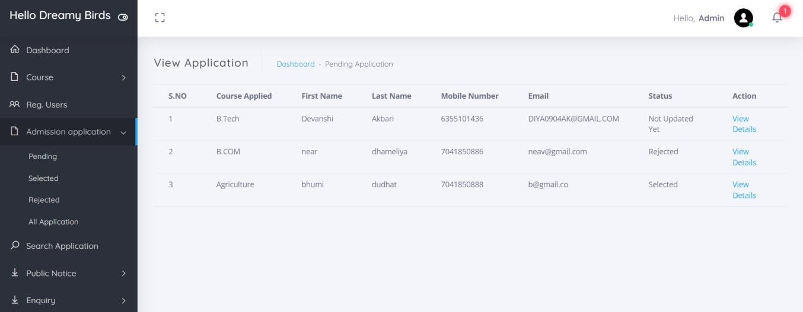



## SOFTWARE TESTING

#### Software Testing

* Software testing is a critical element of software quality assurance and represents the ultimate review of specification design and coding. Testing is an exposure of a system to trial input to see whether it courses correct output.
* In our project, we had to test each unit to make sure it worked properly and there were no bugs.
* Testing finds errors, it does not correct errors. Software success is a quality of service, on time and within cost. Though testing can revel critical (costly) mistakes. Testing should therefore:
* Validate Performance.
* Detects Errors.
* Identify Inconsistencies.

#### Test Objective

* There is strong evidence that effective requirement management leads to overall project time savings. The three primary reasons for this are:
* Requirement errors typically error well over 10 times more to repair than other errors.
* Requirement errors typically comprise over 40% of all errors in a software project.
* Small reduction in the number of requirement errors pays big dividends in avoided rework costs and schedule delays.
* The testing procedure should care for all of these, as well as, in order to attain a flawless, error- free and efficient functioning system; too, software testing is an important phase of any software development life cycle. Various reports and data used for the same are the core of the system. The testing, therefore, becomes important in order to maintain the cost as well as improve performance and consistency. The testing procedure for the system has been divided in to various parts ranging for single unit testing to entire system testing.



#### Test planning evolves the following steps:

* + Estimate the size and cost of the testing efforts.
  + May allocate test resources.
  + Schedule test activities in accord with other development work.
  + Generate test cases

#### GENERATING TEST CASES

* + A test case is a unit of testing activity. Test cases have three parts:
  + Goal*-* the aspect of the system being tested.
  + Input and System State- data provided to the system under stated conditions.
  + Expected Behavior-the output or action the system should take according to these requirements.

#### TEST CASE SELECTION

White-box testing which is based on the internal structure of the system, may also called as testing to code, path-oriented testing, or logical-driven testing. A common goal of white-box testing is to have a test case to exercise every path through a program. This may become exhaustive.

#### WHITE BOX TESTING CASE SELECTION

Because exhaustive white-box testing is infeasible, test or code coverage metrics are used to select test cases, which measure the fraction of code exercised by test cases. Test cases are selected to achieve target test coverage levels.



#### TEST COVERAGE METRICS

* **Statement Coverage**: The fraction of statements executed at least once is running a collection of test cases.
* **Branch Coverage**: The fraction of total branch directions that have been taken at least once in running a collection of test cases.
* **Path Coverage**: The fraction of paths taken at least once in running a collection of test cases, where a “path” is defined in some way to limit the totals of feasible collection.

#### UNIT TESTING

* The presented system is tested first using unit testing. Unit testing is test of code written by a single programmer. A unit is a portion of a system implemented by a single programmer.
* Unit testing is exercising a unit in isolation from the rest of the system. The system, then, is tested using Integrating Testing.

#### INTEGRATION TESTING

* + **Top-Down:** Combine, test and debug top-leveled routines that become the integration test that harms for lower-level units.
  + **Bottom-Up:** Combine, test low-level routines into progressively larger modules and subsystems.
  + **Sandwich:** Mainly top-down with bottom-up integration and testing applied to certain widely used components.



#### FAILURE AND RECOVERY

The system is tested using sandwich testing so as it has integrated advantages of both the top-down integration as well as bottom-up integration testing.

#### ADVANTAGES OF USING TOP-DOWN INTEGRATION

* + The top levels of the system are tested the most.
  + Distributes integration and testing throughout the coding phase.
  + Tends to make bug location easier.
  + Minimizes test harms creation.

#### ADVANTAGES OF USING BOTTOM-UP INTEGRATION

Works well early in the integration process; thorough testing is possible and bugs are easy to be found.

#### TEST COMPLETION

* + White-box test coverage targets are met.
  + Rate of error discovery reduced the target value.
  + Measured reliability of the system achieves its target value.



## LIMITATION AND SYSTEM ENHANCEMENT

#### Limitation

Online Admission System is limited to only for one institute, college or university, so that we are not providing selection between more than one institute, collage, university.

Students is not directly interacting with courses rather he should be sure that he or she selects the best course that is choose for him future.

#### Future Enhancement

We are going to enhance the student selection between more than one university for online admission system so that student has no worried about the right education system he or she has a large number of selection for his or her education

We also want enhance the forum module for internal messaging communication between the students so that all the students will directly communicate with admin and may also share the problems or how to solve it.



## BIBLIOGRAPHY

* **References**

#### Figure:2.2.1:

* (Source: <https://www.geeksforgeeks.org/architecture-of-mysql/>)

#### WEBSITES:

1. [**http://www.phptutorial.com**](http://www.phptutorial.com/)
2. [**http://www.easyphpwebsites.com**](http://www.easyphpwebsites.com/)
3. [**http://www.bestphpwebsites.com**](http://www.bestphpwebsites.com/)
4. **https:**[**//w**](http://www.php.net/manual/en/index.php)**ww**[**.php.net/manual/en/index.php**](http://www.php.net/manual/en/index.php)

##### https:[//w](http://www.killerphp.com/)ww[.killerphp.com](http://www.killerphp.com/)

1. **https:**[**//w**](http://www.tutorialspoint.com/php/)**ww**[**.tutorialspoint.com/php/**](http://www.tutorialspoint.com/php/)

##### https:[//w](http://www.w3schools.com/php/default.asp)ww[.w3schools.com/php/default.asp](http://www.w3schools.com/php/default.asp)

1. **https://stackoverflow.com/questions/tagged/php**

#### BOOKS:

##### PHP 5 Power programming.

1. **PHP MySQL bible.**

##### PHP Manual.